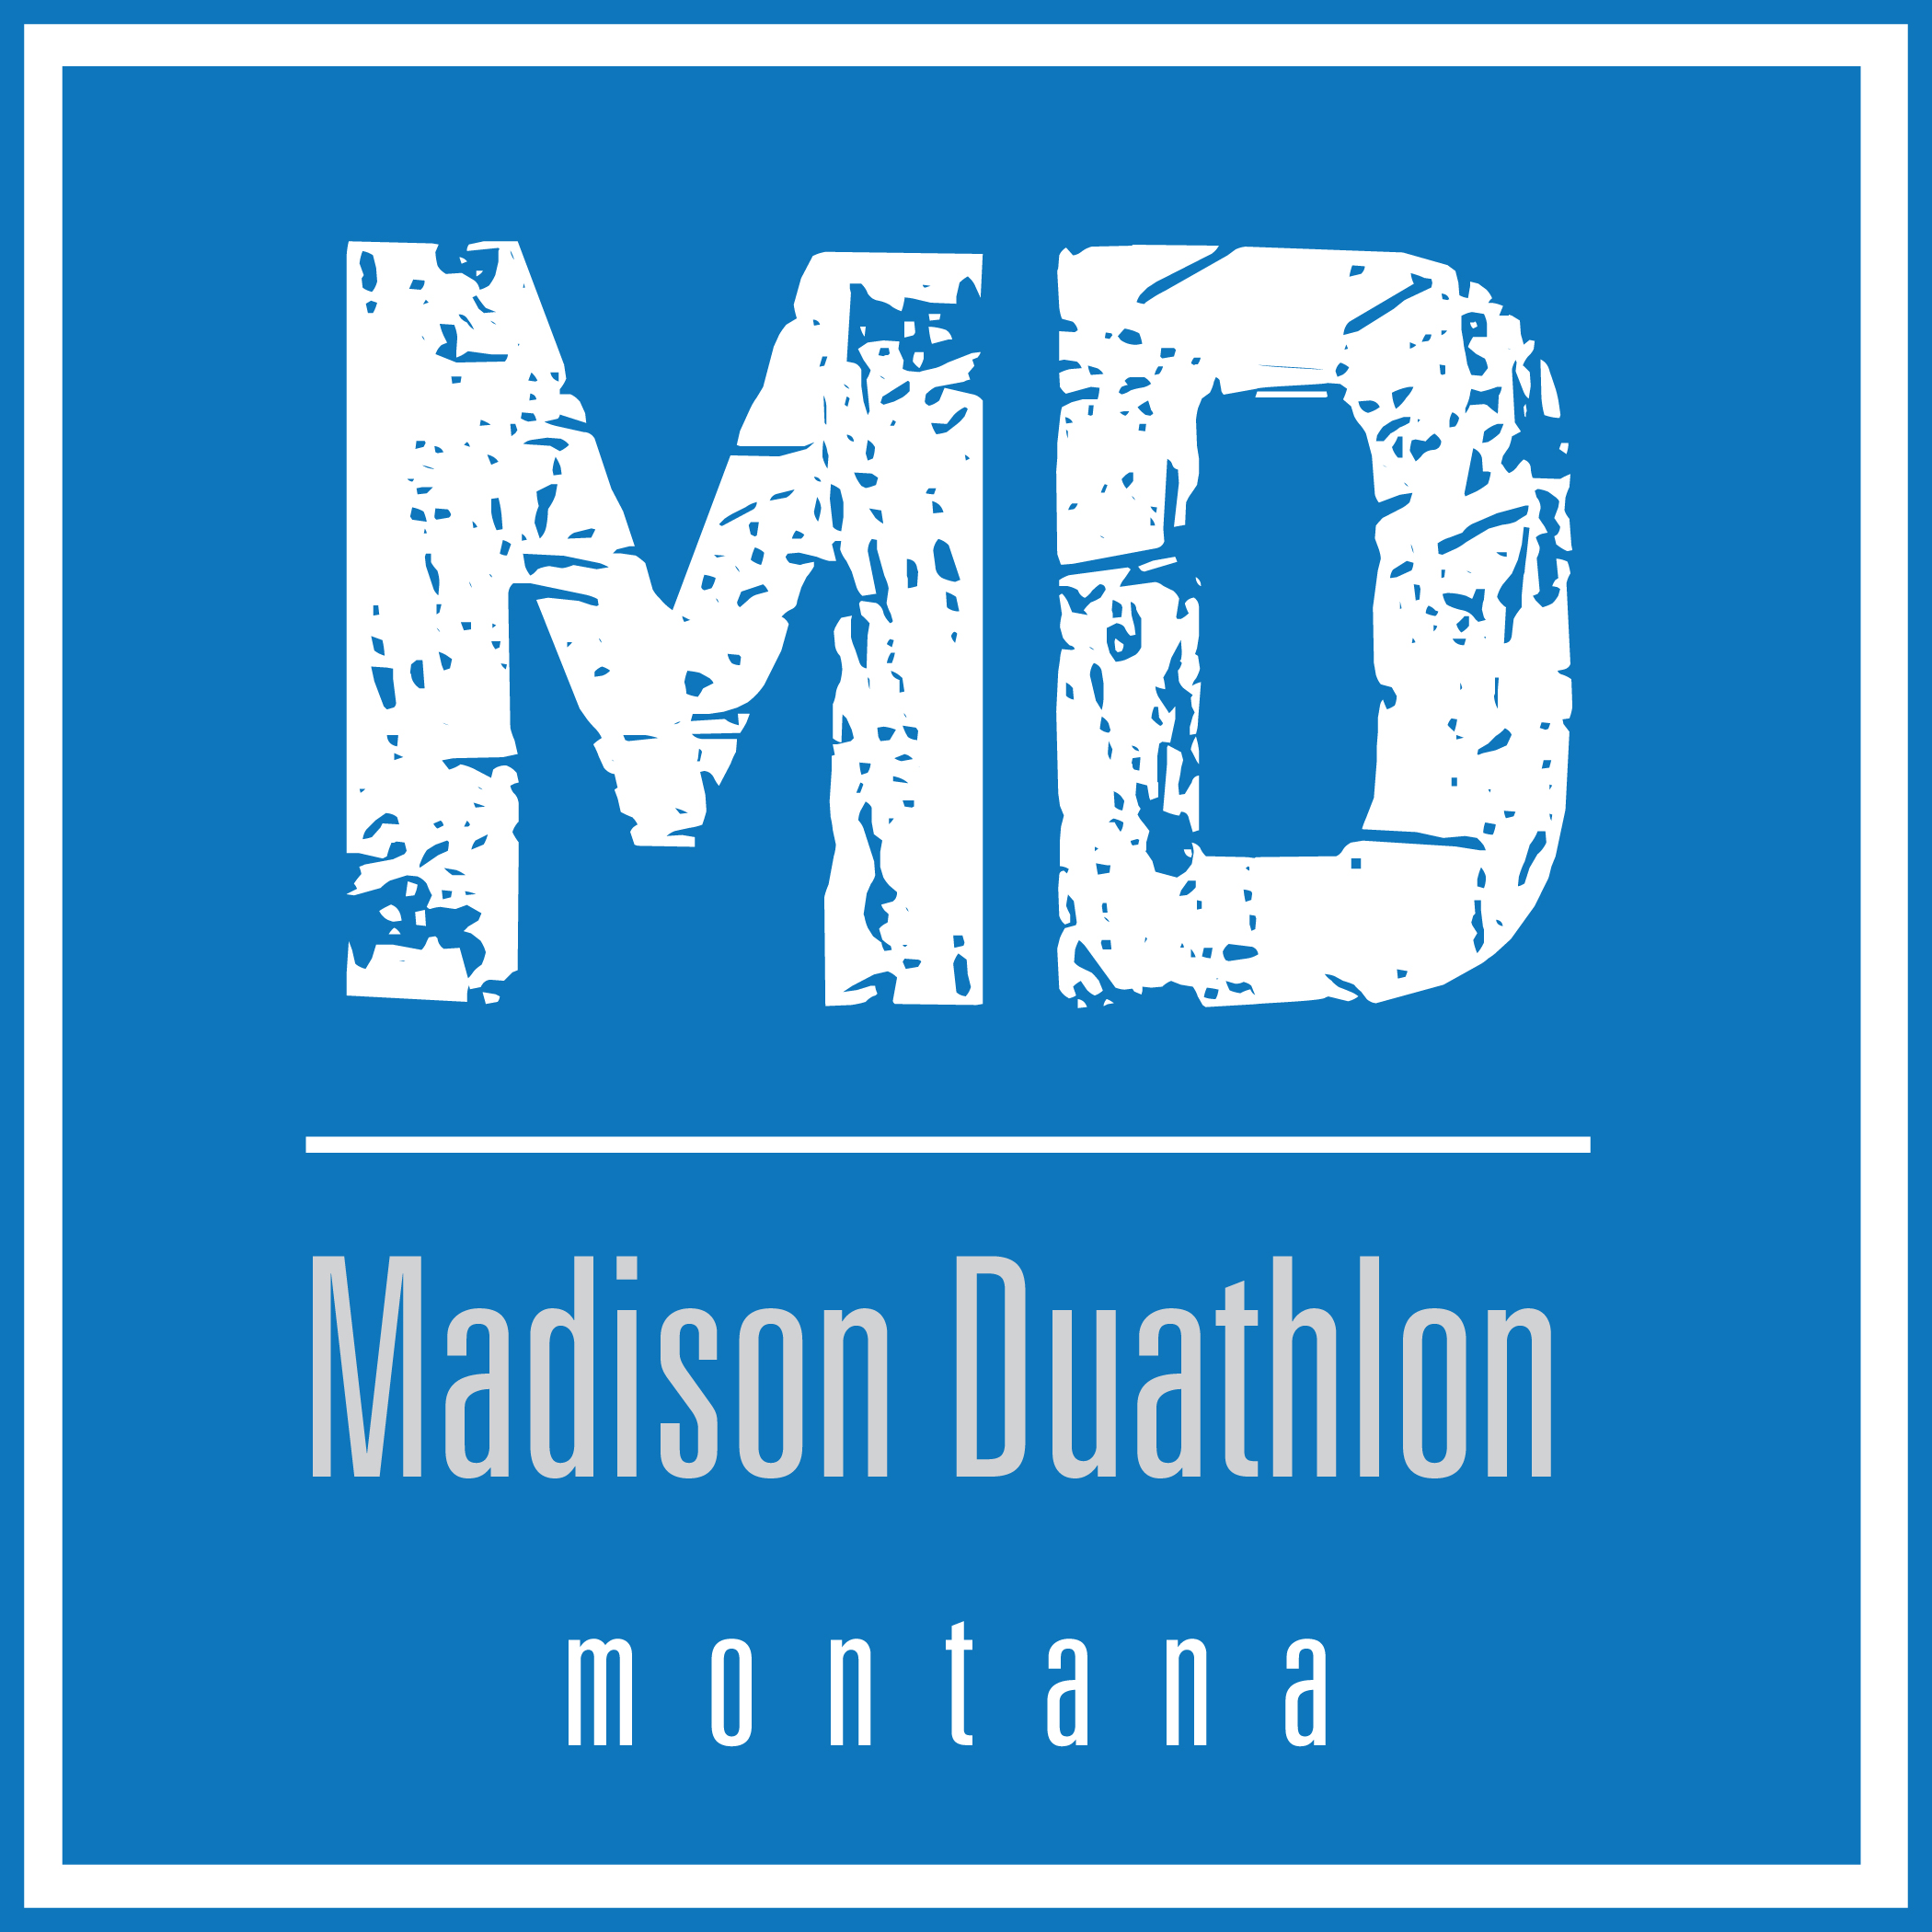

The 7th Annual Madison Duathlon

July 8, 2018

The Gold Miners Trail - Ennis to Virginia City

Official Race Results

Overall Champions

Men’s Division Women’s Division
Neal Andrews Reagan Coyler
Bozeman, MT Ennis, MT
2:07:27 2:14:41

Runners-Up
Michael Stambaugh Sarah Holexa
Great Falls, MT Missoula, MT
2:30:05 2:43:33

Master’s Champions
Men’s Division Women’s Division
Neal Andrews Sarah Holexa
Bozeman, MT Missoula, MT
2:07:27 2:43:33

Runners-Up
Jeff Millsap Lynda Andros-Clay
Virginia City, MT Ennis, MT
2:34:20 2:50:30

Overall

- Neal Andrews – Bozeman, MT 2:07:27
- Corey Hardy – Ennis, MT 2:09:05*
- Reagan Coyler – Ennis, MT 2:14:41
- Michael Stambaugh – Great Falls, MT 2:30:05
- Dylan Malloy – Billing, MT 2:32:15*
- Jeff Millsap – Virginia City, MT 2:34:20
- Eduardo Garcia – Gallatin Gateway, MT 2:36:34
- Eric Huff – Sheridan, MT 2:36:55
- Ed Hays – Laguna Beach, CA 2:41:24
- Sarah Holexa – Missoula, MT 2:43:32
- Natalie Deschamps – Missoula, MT 2:43:35
- Emily Taylor – Marysville, MT 2:47:15
- Mariah Vandiver – Burleson, TX 2:48:47
- Lynda Andros-Clay – Bozeman, MT 2:50:30
- Matt A – Boulder, Colorado 2:52:39
- Stan Wagner – Bozeman, MT 2:53:21
- Carrie Egging – West Yellowstone, MT 3:14:14
- Tyler Behm – West Yellowstone, MT 3:14:50
- Michael Moline – Great Falls, MT 3:26:51
- Dena Maddison – Alder, MT 3:44:59
- Ryan Maddison – Alder, MT 3:44:59
- Tiffany Dupree – Helena, MT 3:47:05
- Amanda Flamm – Dillon, MT 3:51:41

* Not on race day

Men’s Overall

- Neal Andrews – Bozeman, MT 2:07:27
- Corey Hardy – Ennis, MT 2:09:05
- Michael Stambaugh – Great Falls, MT 2:30:05
- Dylan Malloy – Billing, MT 2:32:15
- Jeff Millsap – Virginia City, MT 2:34:20
- Eduardo Garcia – Gallatin Gateway, MT 2:36:34
- Eric Huff – Sheridan, MT 2:36:55
- Ed Hays – Laguna Beach, CA 2:41:24
- Matt A – Boulder, Colorado 2:52:39
- Stan Wagner – Bozeman, MT 2:53:21
- Tyler Behm – West Yellowstone, MT 3:14:50
- Michael Moline – Great Falls, MT 3:26:51
- Ryan Maddison – Alder, MT 3:44:59

Women’s Overall

- Reagan Coyler – Ennis, MT 2:14:41
- Sarah Holexa – Missoula, MT 2:43:32
- Natalie Deschamps – Missoula, MT 2:43:35
- Emily Taylor – Marysville, MT 2:47:15
- Mariah Vandiver – Burleson, TX 2:48:47
- Lynda Andros-Clay – Bozeman, MT 2:50:30
- Carrie Egging – West Yellowstone, MT 3:14:14
- Dena Maddison – Alder, MT 3:44:59
- Tiffany Dupree – Helena, MT 3:47:05
- Amanda Flamm – Dillon, MT 3:51:41

