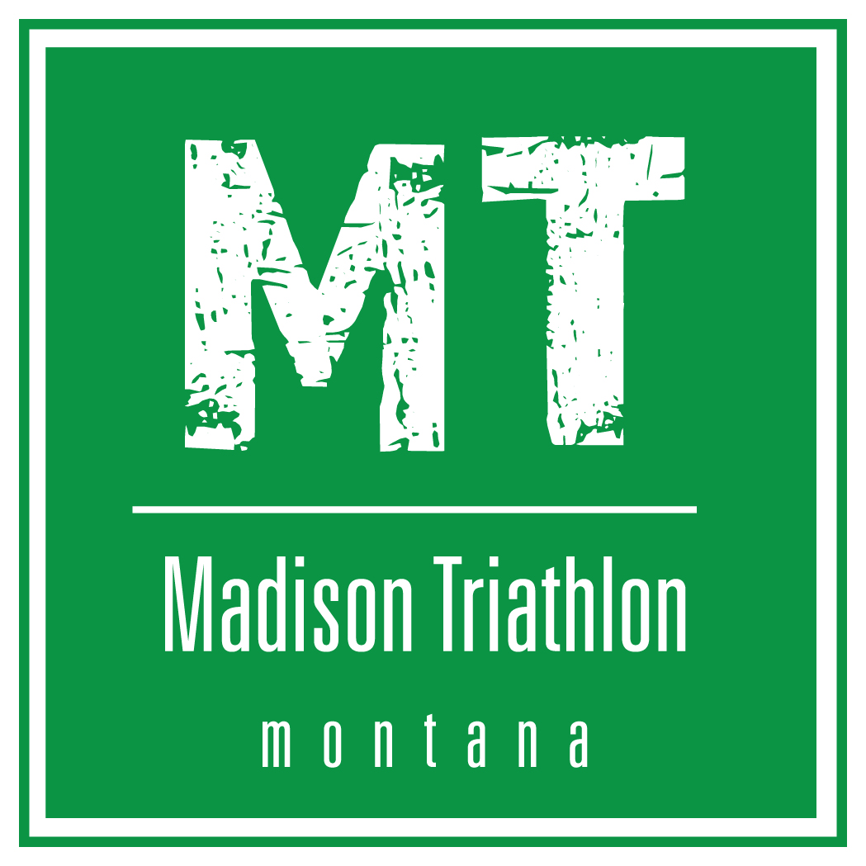

The 7th Annual Madison Triathlon

August 4, 2018

Montana’s Greatest Olympic Distance Triathlon

Official Race Results

Overall Champions

Men’s Division Women’s Division

Ingram Crossom 2:36:50 Kathleen Snider 3:00:03
Tuscaloosa, AL Belgrade, MT

Runners-Up

Dylan Malloy 2:34:46 Makenzie Kink 3:00:05
Ennis, MT Austin, TX

Master’s Champions
Men’s Division Women’s Division

Corey Hardy 2:52:47 Lynda Andros-Clay 3:31:28
Ennis, MT Bozeman, MT

Runners-Up

Ed Hays 2:54:53 Amanda Flamm 5:03:42
Laguna Beach, CA Dillon, MT

Overall

- Ingram Crossom – Tuscaloosa, AL 2:36:50
- Dylan Malloy – Billings, MT 2:34:46
- Corey Hardy – Ennis, MT 2:52:47
- Ed Hays – Laguna Beach, CA 2:54:53
- Ryan Prosser – San Francisco, CA 2:55:28
- Kathleen Snider – Belgrade, MT 3:00:03
- Makenzie Kink – Austin, TX 3:00:05
- Eduardo Garcia – Gallatin Gateway, MT 3:02:33
- Carrie Egging – West Yellowstone, MT 3:19:58
- Sumner Lavalley – Bozeman, MT 3:24:49
- Lynda Andros-Clay – Bozeman, MT 3:31:28
- Katie Ebert – Bozeman, MT 4:04:54
- Matt A – Boulder, Co 4:32:25
- Amanda Flamm – Dillon, MT 5:03:42

Men’s Overall

- Ingram Crossom – Tuscaloosa, AL 2:36:50
- Dylan Malloy – Billings, MT 2:34:46
- Corey Hardy – Ennis, MT 2:52:47
- Ed Hays – Laguna Beach, CA 2:54:53
- Ryan Prosser – San Francisco, CA 2:55:28
- Eduardo Garcia – Gallatin Gateway, MT 3:02:33
- Matt A – Boulder, Co 4:32:25

Women’s Overall

- Kathleen Snider – Belgrade, MT 3:00:03
- Makenzie Kink – Austin, TX 3:00:05
- Carrie Egging – West Yellowstone, MT 3:19:58
- Sumner Lavalley – Bozeman, MT 3:24:49
- Lynda Andros-Clay – Bozeman, MT 3:31:28
- Katie Ebert – Bozeman, MT 4:04:54
- Amanda Flamm – Dillon, MT 5:03:42

Age Groups

Men

Men 20-29
- Ingram Crossom – Tuscaloosa, AL 26 2:36:50

Men 30-39
- Dylan Malloy – Billings, MT 32 2:34:46
- Ryan Prosser – San Francisco, CA 39 2:55:28
- Eduardo Garcia – Gallatin Gateway, MT 36 3:02:33

Men 40-49
- Corey Hardy – Ennis, MT 43 2:52:47
- Matt A – Boulder, Co 42 4:32:25

Men 50-59
- Ed Hays – Laguna Beach, CA 52 2:54:53

Women

Women 20-29
- Kathleen Snider – Belgrade, MT 24 3:00:03
- Makenzie Kink – Austin, TX 25 3:00:05
- Sumner Lavalley – Bozeman, MT 24 3:24:49

Women 30-39
- Carrie Egging – West Yellowstone, MT 31 3:19:58
- Katie Ebert – Bozeman, MT 33 4:04:54

Women 40-49
- Lynda Andros-Clay – Bozeman, MT 42 3:31:28

Women 50-59
- Amanda Flamm – Dillon, MT 51 5:03:42

